

**Data Science and Analytics: Assignment 2**

TOLOLI ONLINE STORE Recommendation System Algorithm: On Games Products

by

Mateus Iyambo

Student Number: 217066801

Lecturer: Dr Lamek

**Abstract**

This report discusses the various algorithms that make up the Tololi Online Store recommender system and describes its business purpose. Machine learning algorithms are used by recommender systems to filter omitted information and determine if a user will find a particular resource appealing. Collaborative filtering recommender systems is one of the categories of recommender systems. Tololi online Store searched for a recommendation system algorithm. The algorithm that uses item-item collaborative filtering, with possibilities to scale to massive datasets and produces high quality recommendation system on real time data. In essence, the algorithm foretells the "rating" or preferences that the user that is most likely to be interested in. The project goal intended to give users appropriate product recommendations based on their preferences. The products consumers have previously consumed are typically used to infer preference and relevance, which are both subjective concepts. A recommendation system will assist Tololi online business in developing devoted patrons and trust by getting visitors to the website to purchase the goods and services they were looking for

**Keywords: Recommender System, Python, Tololi Online Store**

**Introduction**

One of the areas of artificial intelligence that is expanding the fastest is recommender systems, which are now incorporated into most online shop solutions. Every element of our lives is in some manner impacted by recommender systems, from personalized advertisements to search query results to recommendations of things packaged together. Like many young people, every member of this team enjoys playing video ports games in particular. As a result, the objective of this project is to create a recommender system for sports games.

Tololi is a Namibian online Store (stylized as tololi) is an online marketplace and sourcing service, tailored for a convenient online shopping experience. For this project we used the data scrapped from Tololi Online Store website on one particular vendor (Gaming Add Ons) the biggest video game digital distribution service for sports games. The datasets utilized is detailed in more detail in this blog. We used some rating data and gamesdata data. The main goal of this project to build a recommendation system algorithm that will recommend sport games for each user based on their preferences and gaming habits. Multiple algorithms used in our recommendation system to make it as effective as possible. And manipulated into practice and contrasted to make recommendation as pertinent to each user as feasible.

**Related work**

The present work explores the importance of high-level visual content using constant attributes for online recommendation systems for computer video games. Prior to the recommendation system, the most common buying behavior was to follow anyone recommendation without informed bases on the games. Because of your search, watch, and purchase histories, many search engines now knows what news you'll read, and knows the kinds of games you'll play. Many developers have used data for a recommendation system that can be explicit, such as views or rating, or implicit, such as behavior and events like order history, search logs, clicks, etc. Although it is more difficult to analyze implicit data because it is difficult to separate useful information from irrelevant information, it is simpler to obtain than explicit data because the user need only use the website or app as usual. The online store industry has grown significantly in recent years, making it difficult to make decisions while interacting with vast amounts of information. The current studies can be divided into three categories: online product recommendations, online production process recommendations, and user recommendations for products. Although there are many different elements utilized in online recommendation systems algorithm, research to date indicates that metadata, profile expansion, textual and visual features, and ratings are the most often employed features. The code source attached displays a few cutting-edge techniques for (products) games suggestion. Recently, several researchers have given in-game product recommendations to players attention based on the game's requirements.

**Methods**

Tololi Online Recommender System algorithm is developed using recommendation system as a recommendation engine that uses classes of machine learning which presents the customer with pertinent suggestions. Many developers have used existing datasets, their limitations, and the need for a new proposed dataset. For the requirement of this project the data was scrapped from the Tololi Online Store website and saved into csv file.

Data:

Tololi recommendation systems needed a large dataset for learning models and recommendations. To the best of our knowledge, there is no datasets are available from Tololi Store that can be used for recommendation systems algorithm.

Data Collection and Preparation:

Google Scrapper is used to build the dataset and saved into scv file. The data saved including user, rating, and game content. Games data are chosen for data scraping because it offers abundant semantic visual features for model learning and attributes for data suggestion. In addition, games have been split up into several item id and each item id contain semantic data related to it.

Value Metrics:

Item-based recommendations are carried out utilizing item ranking accuracy models, according to the project requirement on recommendation systems. The performance of the models serves as the basis for the evaluation metric for ranking prediction, and we assess the performance using the evaluation metrics. The metrics rank the games on the list and measure performance recommendation systems. As a result, these measures are utilized to assess the performance and evaluate outcomes in relation to basslines.

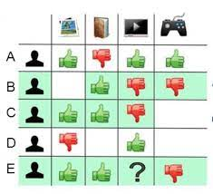

Figure 1: The diagram shows item-item game collaborative filtering model

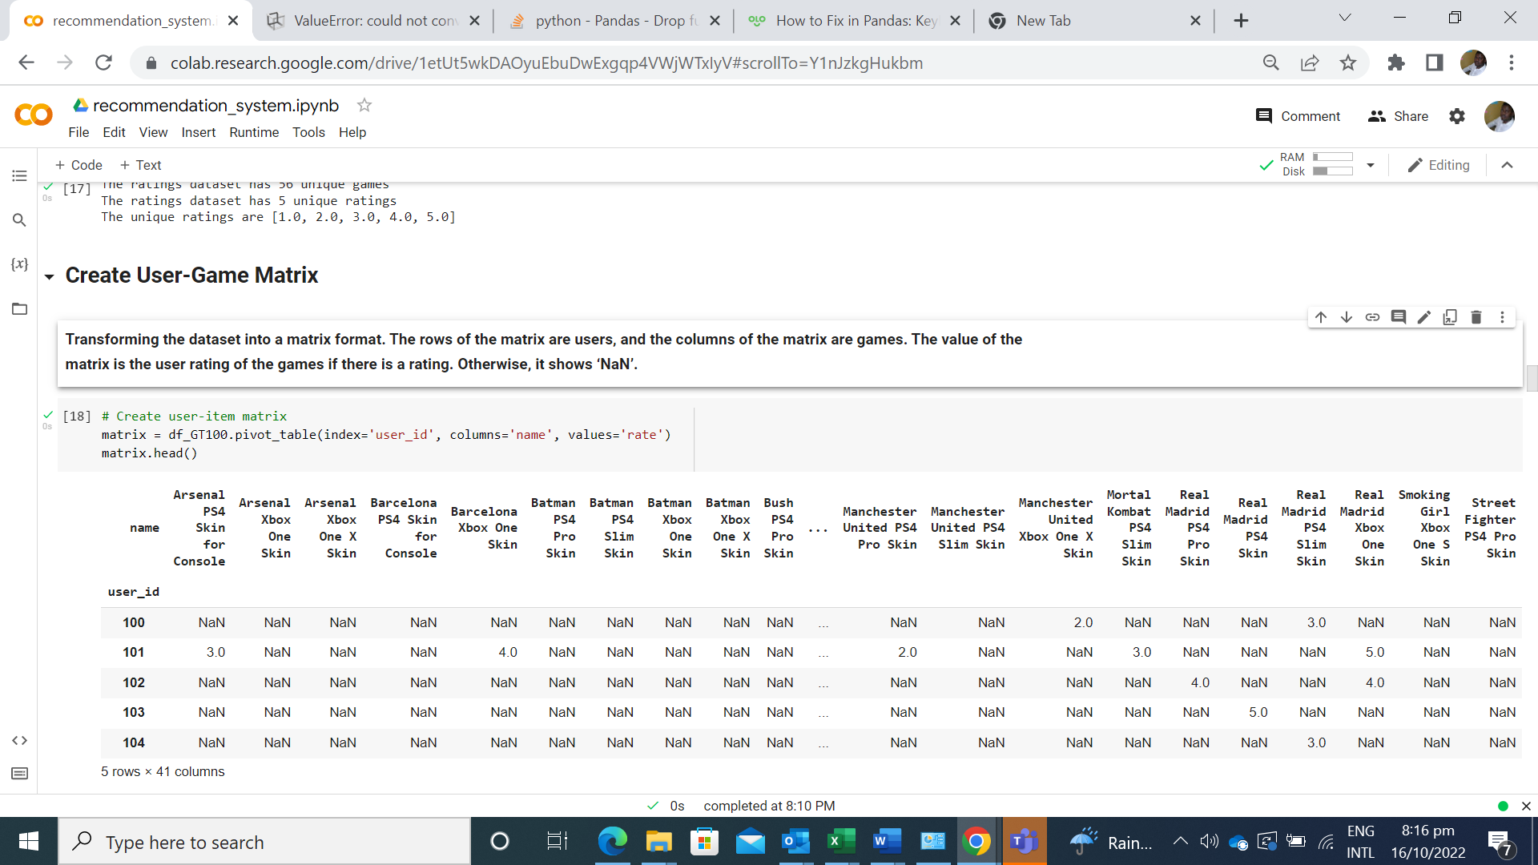

Figure 2: Collaboration Game Recommender System

**Results / Discussion**

We contrast our findings with the algorithms used for game recommendation. We contrast the outcomes of game attributes with conventional recommendation techniques like item id and game details. The stated outcomes have demonstrated that the suggested strategy offers superior accuracy and performance. We get to the conclusion that the training and recommendation capabilities of the game data and rate datasets. There is a ton of implicit and explicit preference data about users and objects in the game features. The model can better understand the relationship between users and objects with the use of this information. Fortunately, the outcomes demonstrate that our methodology produced superior outcomes. This work is based on item-to-item collaboration recommendations along with sport video games features. To enhance the performance of recommendations, a deep neural network with a factorization machine is deployed.

**Output**

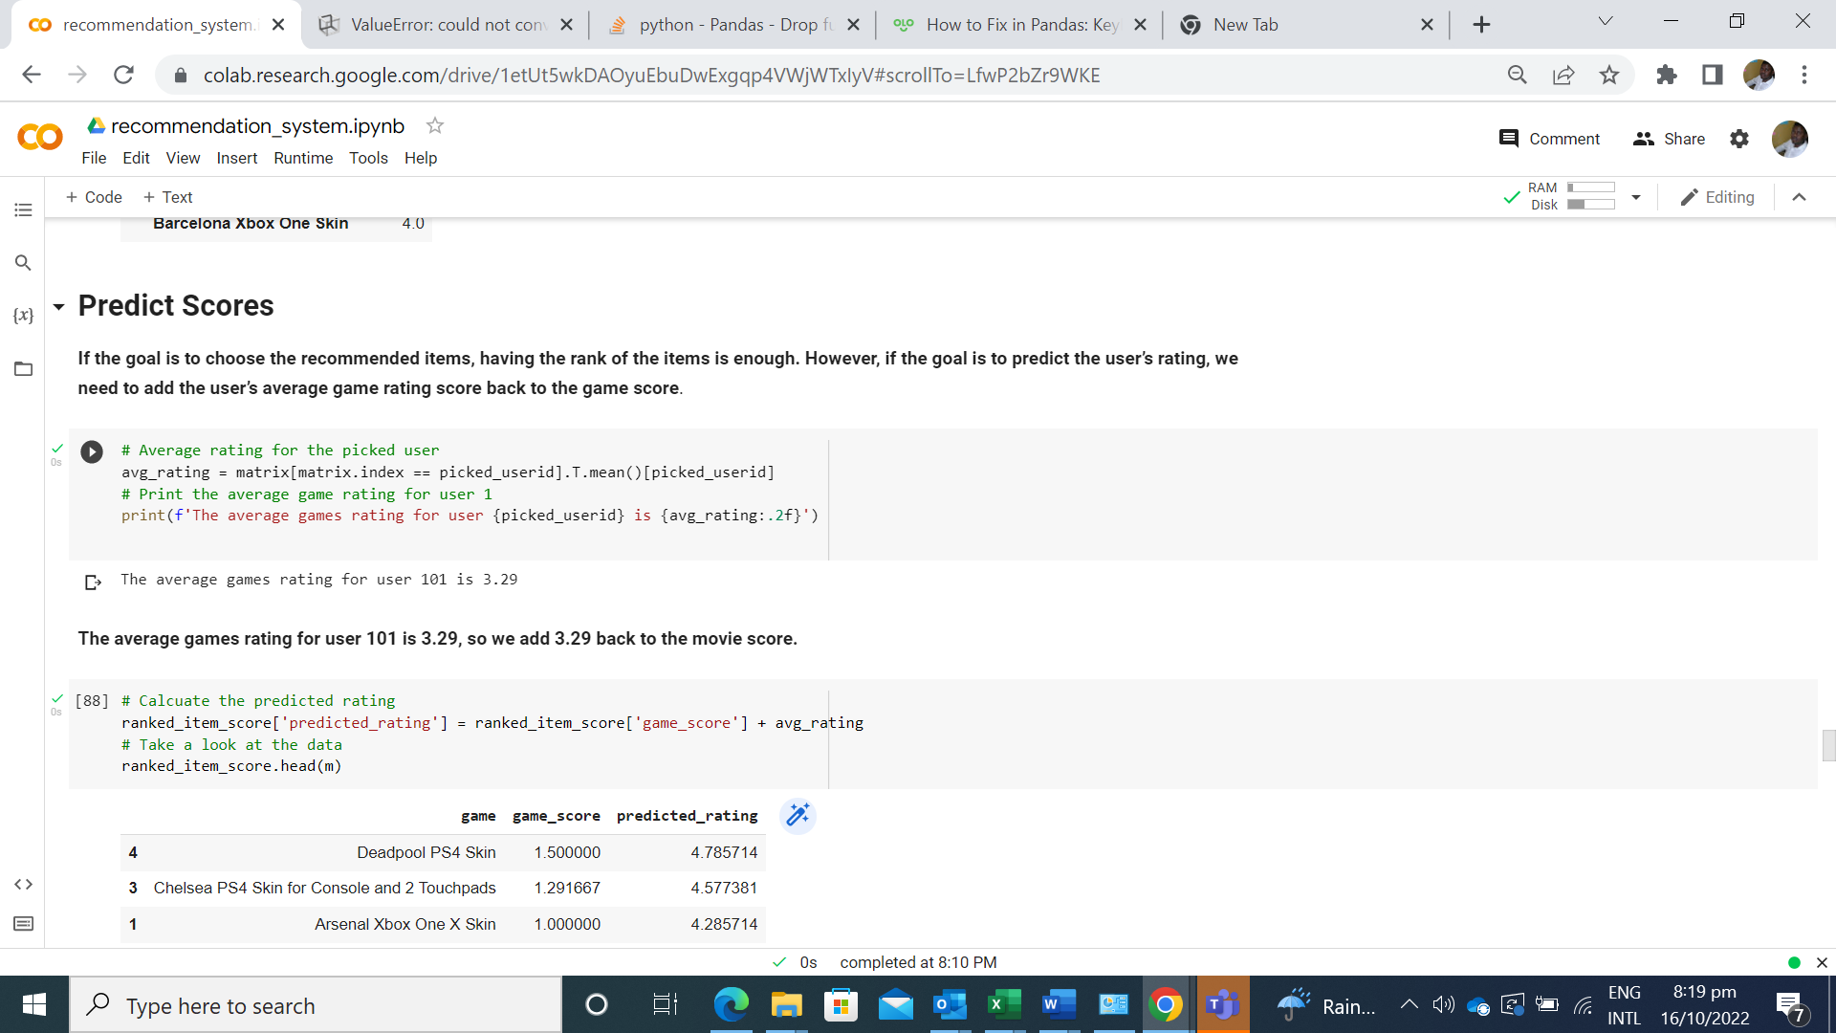

Figure 3: Predict Score

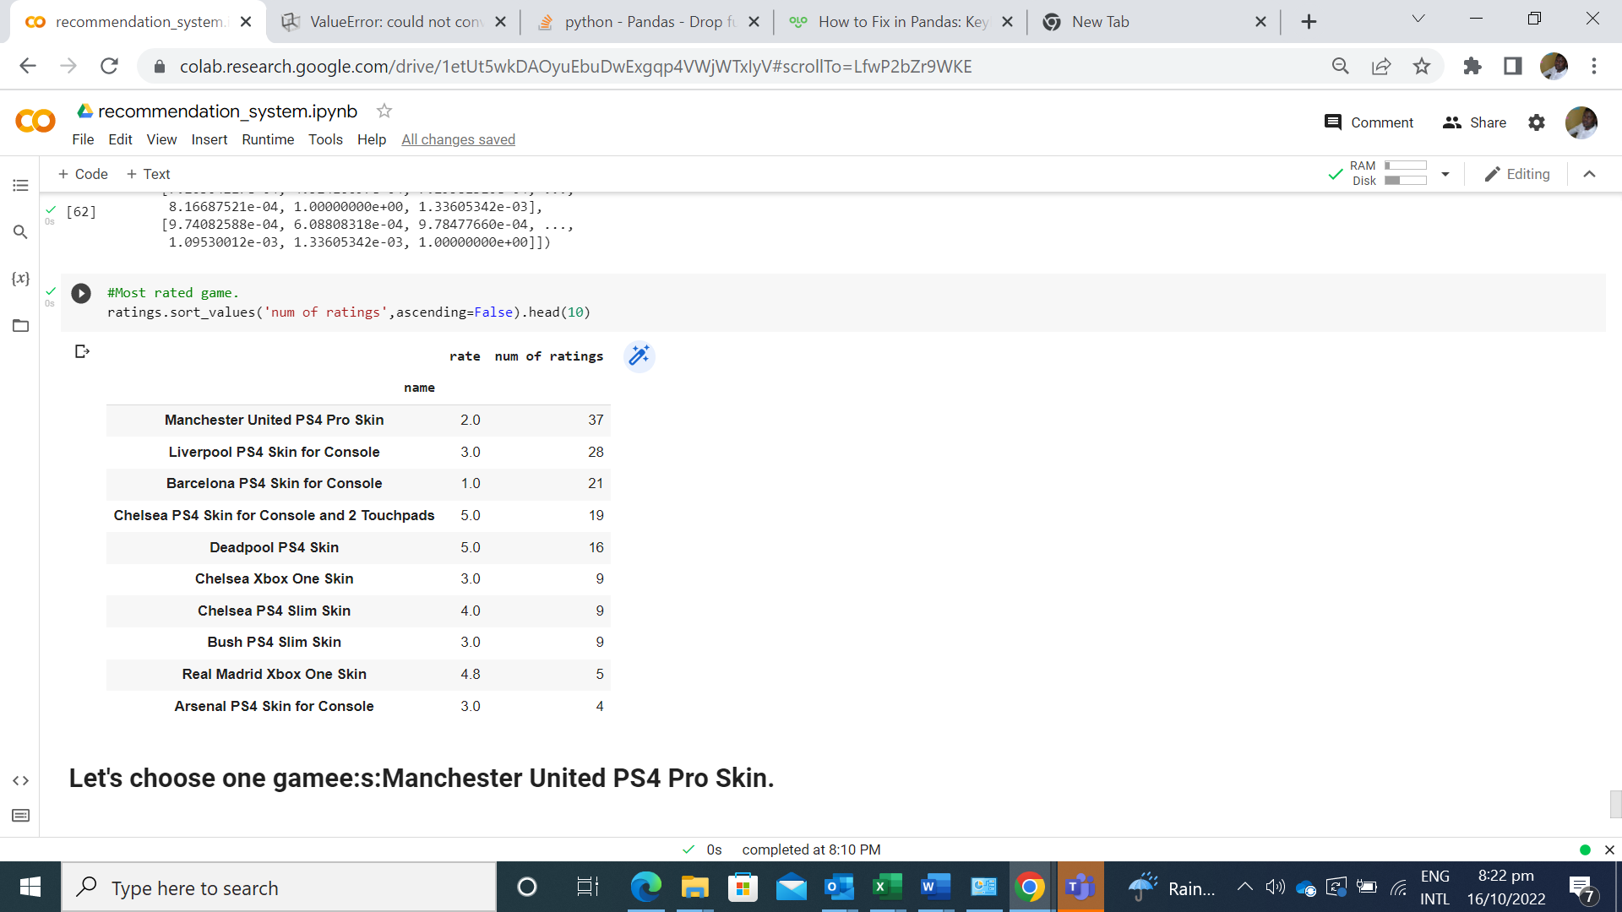

Figure 4: The most rated Game

**Links: GitHub**

**Conclusion**

The main goal of this project was to build a recommendation system algorithm for Tololi Online Store that will recommend sport games for each user based on their preferences and gaming habits. Multiple algorithms used in our recommendation system to make it as effective as possible. And manipulated into practice and contrasted to make recommendation as pertinent to each user as feasible.

# **References**

Batu, E., & Wilson, G. (2017). CHATBOT FOR COLLEGE ENQUIRY. *International Journal of Creative Research Thoughts*.

Kumar, S., Khan, S., Manav, S., Saurav, V., & Patil, S. (2018). Chatbot for College Website. *International Journal of Computing and Technology*.

Moore. (2017). Chatbot for Student Admission Enquiry. *Advancement in Software Engineering and Testing*.

Ms.Ch.Lavanya Susanna and R. Pratyusha. (2020). COLLEGE ENQUIRY CHATBOT. *International Research Journal of Engineering and Technology (IRJET)* .

<https://medium.com/analytics-vidhya/understanding-recommender-systems-introduction-3be54e937625>

https://medium.com/grabngoinfo/recommendation-system-user-based-collaborative-filtering-a2e76e3e15c4#id